02/12/2020

The methods we can use implement jQuery with webapck
- using import statement (main branch )
- using externals
- using webpack.providePlugin
- modifying jQuery source code
- using import function with Promise or async function

git link for do demostration:-
https://github.com/Direct-Entry-Program/webpack-with-jquery

2009 - node introduced
2015 - ECMAScript6 introduced and module concept was introduced to ecmascript6

“module mean” – exmaple like a class →organize and keep methods variables in some scope

2009 to 2015 → no module concepts in java scripts

IIFE – Immediatly Invoked Function Expression

The var statement declares a function-scoped or globally-scoped variable, optionally initializing it to a value.
No block leve scope for “var”. The variables defined in blocks also created in global scope.
Example:-
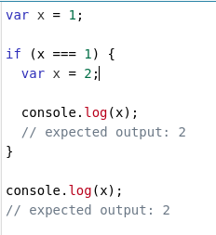

problem: - there are many variables in global scope. Therefore sometimes same variable may define in two places in the script.

